**Project Report**

* **INTRODUCTION**
  1. OVRVIEW

My project is to create a movie ticketing chat bot using **IBM Watson Assistant** service. In this project, we will be building a chat bot using Watson assistant. This chat should have the following capabilities

* Give the list of movies available
* The Bot should be able to show different show timings
* When a movie is selected the bot should show the availability of tickets and their respective prices.
* The bot should be in a position to book tickets
  1. purpose
* **The use of this project is that users can easily understand how to book tickets and they will easily know the details of movies like show timings, ticket prices etc.**
* **Time will be saved to the users.**
* **LITERATURE SURVEY**
  1. **Existing problem**

**Existing approaches or methods to solve this problem is IBM Watson Assistant.**

* **THEORITICAL ANALYSIS**
  1. **Block diagram**

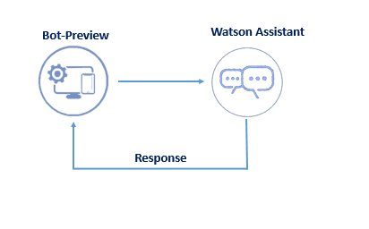

* 1. **Hardware/ Software designing**

**IBM Watson Assistant is the software requirement of the project.**

* **EXPERIMENTAL INVESTIGATION**

**Watched lecturer videos delivered by training faculty of smart Internz.**

* **FLOWCHART**

WELCOME MESSAGE

GREETINGS

RESPONSE FROM WATSON ASSISTANT

INPUT /QUESTIONS FROM USER

* **RESULT**

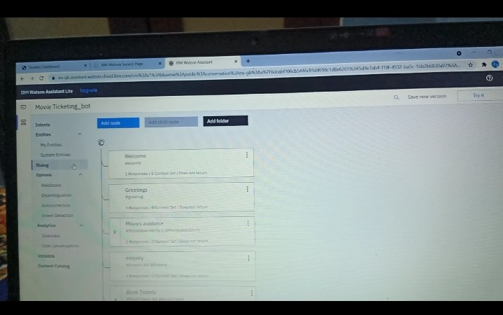

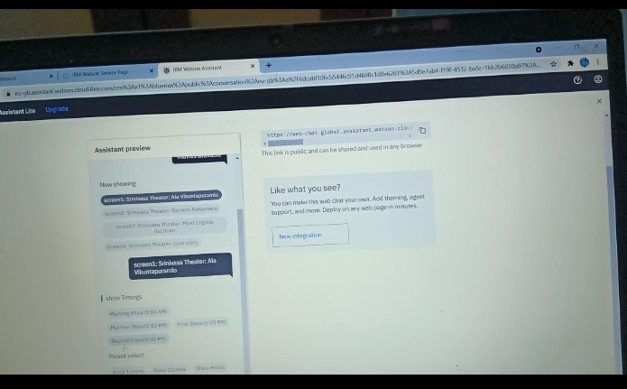

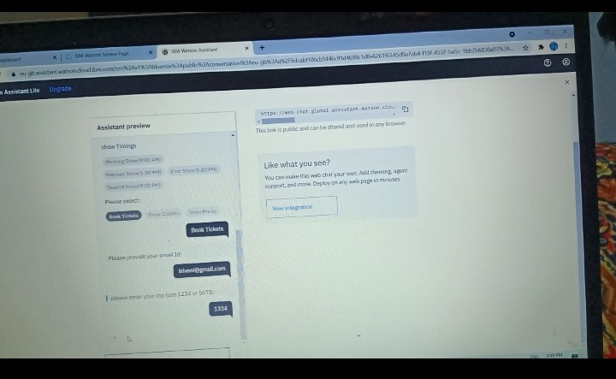

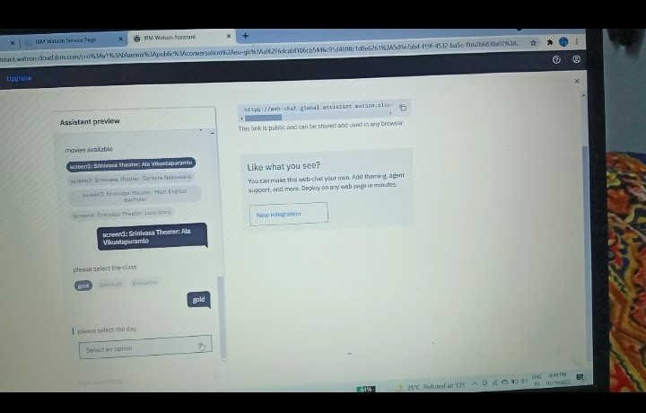

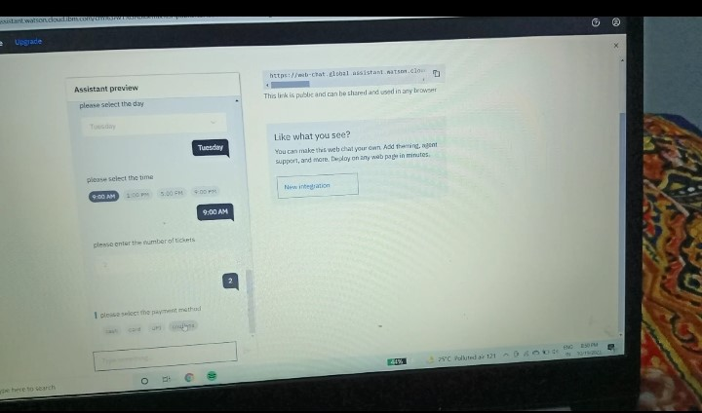

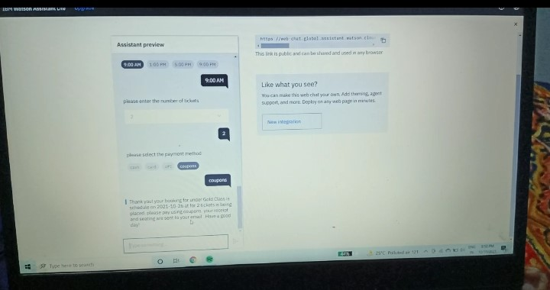

* **ADVANTAGES AND DISADVANTAGES**

ADVANTAGES:-

* Reduced costs.
* 24-7 availability.
* Multiple customer handling.

DISADVANTAGES:-

* Increased Installation cost.
* Complex Interface.
* **APPLICATIONS**

It is a software solution can be used in

* Mobile phones to book tickets.
* Social websites like facebook, twitter etc..
* Paytm, Gpay ect..
* **CONCLUSION**

Here I am concluding that it is a very useful software solution. We can easily construct chat bot like movie ticketing bot by using Watson assistant.

**10. FUTURE SCOPE**

In future we can enhance this application according to future technology.